Experiment no. 1
Title:
A Detailed Study on Java Programming Language: History, Uses, Advantages, and Limitations.

Objectives:
The main objectives of this lab are:
- To understand the history and evolution of the Java programming language.
- To learn the main features and real-world uses of Java.
- To identify the advantages and disadvantages of Java.
- To develop basic knowledge about Java for future software development.

Introduction:
Java is one of the most popular and widely used programming languages in the world. It is a high-level, object-oriented, and platform-independent programming language. Java is used in software development, mobile applications, web systems, and enterprise solutions. Due to its security, reliability, and portability, Java is still highly demanded in modern technology industries.

History of Java:
Java was developed in 1991 by James Gosling and his team at Sun Microsystems. Initially, the language was designed for electronic devices like set-top boxes and smart appliances.
The project was first named “Oak” but later renamed “Java” in 1995. The main goal of Java was to create a language that could run on any platform without modification.
In 2010, Oracle Corporation acquired Sun Microsystems and became the owner and maintainer of Java.

Uses of Java:
Java is used in many sectors, such as:
1. Mobile Application Development
Android apps are mostly developed using Java.
2. Web Development
Java is used to build dynamic and scalable web applications.
3. Enterprise Software
Large companies use Java for banking, finance, and management systems.
4. Desktop Applications
Java is used for GUI-based applications.
5. Cloud and Big Data
Java plays an important role in big data technologies.
6. Game Development
Some games and simulations are built using Java.

Advantages of Java:
- Platform independence (Write Once, Run Anywhere).
- Strong security and reliability.
- Large community and support.
- Object-oriented structure improves code reuse.
- Automatic memory management.
- Suitable for large-scale systems.

Disadvantages of Java:
- Slower than some low-level languages like C and C++.
- High memory consumption.
- Complex for beginners compared to some modern languages.
- Requires JVM which increases overhead.
- Less suitable for system-level programming.

Conclusion:
Java is one of the most powerful and stable programming languages. It is widely used in industry because of its portability, security, and object-oriented design. Learning Java can provide strong career opportunities in software engineering, mobile app development, and enterprise solutions

Experiment no.2
Title: Java Program to Display Student Personal Information.
Objectives:
- To understand basic Java syntax.
- To learn how to write and execute a Java program.
- To display user information using Java.
- To practice compiling, debugging, and testing.

Problem Analysis:
The problem is to create a simple Java program that displays student information such as name, ID, age, email, phone number, and address.
The program should run successfully and produce correct output.

Algorithm:
Step 1: Start the program.
Step 2: Declare the main class.
Step 3: Write the main method.
Step 4: Use print statements to display personal information.
Step 5: Compile and run the program.
Step 6: Display output.
Step 7: End.

Coding (Source Code):
public class Parsonal_Information{ // declare the class
public static void main(String[] args) // The program start from the main method.
{
//Defining personal information
int age = 22;
String name ="Fahim Shariar" ;
String id =" E253071";
String email = "md.fahim540fahim@gmail.com";
String phone = "01891606039";
String address =" North Sarai Para,Pahartali, Chattogram.";
// Using println to display the information.
System.out.println("personal Information:");
System.out.println("Name :" + name);
System.out.println("Age :" + age);
System.out.println("ID :" + id);
System.out.println("Email :" + email);
System.out.println("Phone :" + phone);
System.out.println("Address:" + address);

}
}

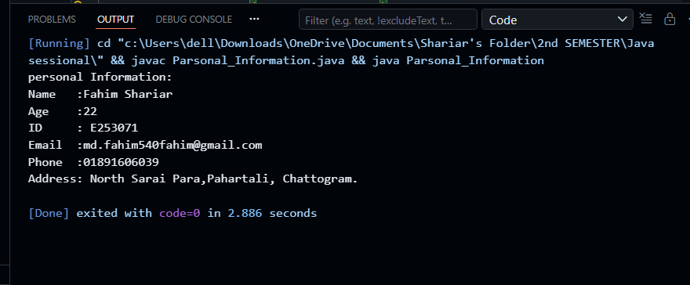
Output:

Discussion & Conclusion:
This lab helped in understanding the basic structure of Java programming. It improved knowledge about writing, compiling, and executing Java programs. The experiment also provided an introduction to object-oriented programming and real-world software development. This foundational knowledge will be useful for future advanced programming and software engineering tasks.

